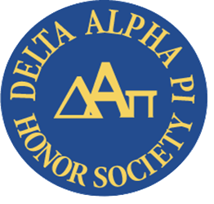
Richland’s Delta Alpha Pi Club works to raise awareness about disability and disability-related issues. Global Accessibility Awareness Day is observed each year on May 20, Delta Alpha Pi is proud to highlight information about Accessibility for the month of May. If you would like to join or learn more about Delta Alpha Pi, please email tmata@richland.edu.

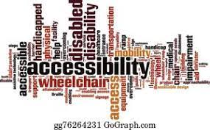
What is Accessibility?
According to the Interaction Design Foundation, Accessibility is the concept of whether a product or service can be used by everyone—however they encounter it. Accessibility laws exist to aid people with disabilities, but designers should try to accommodate all potential users in many contexts of use anyway.
A few basic facts about Accessibility according to disability advocate Sheri Byrne-Haber:
Fact #1: All accessibility (digital and physical) is a civil right.
The Americans with Disabilities Act is a civil rights law for people with disabilities. The vast amounts of successful litigation over inaccessible websites, native mobile apps, and documentation have been driven by plaintiffs with disabilities enforcing those civil rights.
Fact #2: People with disabilities are the largest minority group in the United States.
Depending on what survey you are looking at, the number of people with disabilities ranges between 18 and 26 % of the overall population, larger than any ethnic group. The numbers vary from region to region, with higher rates of disability in the South.

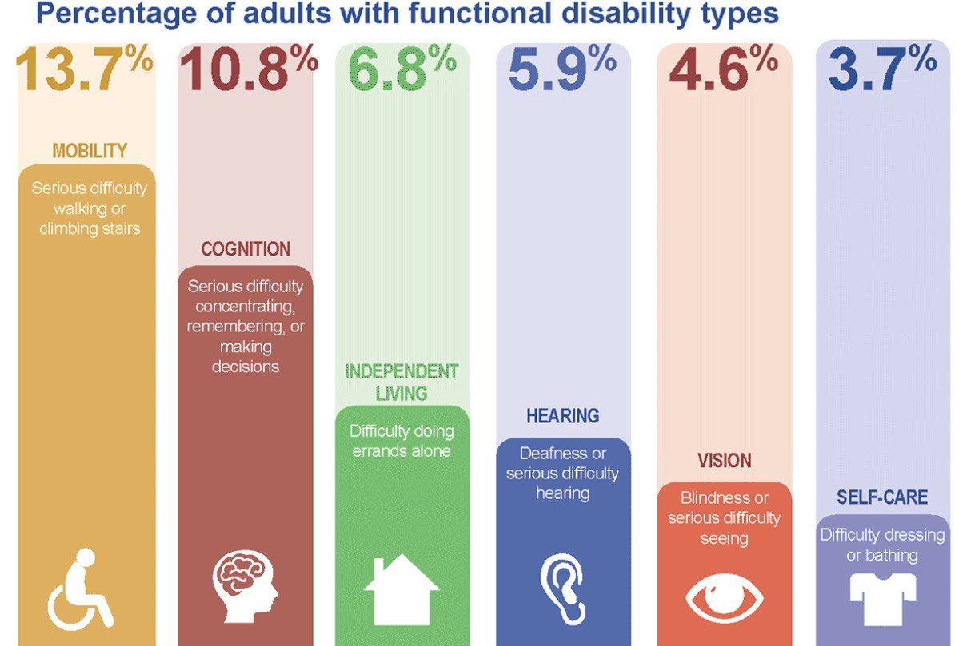
From the CDC: https://www.cdc.gov/ncbddd/disabilityandhealth/infographic-disability-impacts-all.html
- 13.7 % of people have mobility issues making it difficult to walk or climb stairs
- 10.8 % have cognition issues making it difficult to concentrate, remember, or make decisions
- 6.7 % have difficulty performing errands alone
- 5.9 % have hearing loss
- 4.6 % have vision loss
- 3.7 % have difficulty taking care of themselves

Fact #3: Disability is not caused by a medical condition

The impact of a medical condition is not a disability. Society both enacts and enables barriers that cause people to be disabled. That makes society 100 % responsible for both the cause (and the solution) for any disability that any individual experiences.

Check out this mini-documentary titled All the Same to hear the difficulties that people with different types of disabilities face when encountering inaccessible technology. Join us in celebrating Global Accessibility Awareness Day on Thursday, May 20, 2021 by learning more about this important issue!

