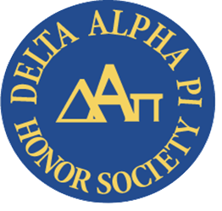
Richland’s Delta Alpha Pi Club works to raise awareness about disability and disability-related issues. April is the awareness month for Autism, with Friday, April 2 being celebrated as World Autism Awareness Day. Delta Alpha Pi is proud to highlight information about Autism for the month of April. If you would like to join or learn more about Delta Alpha Pi, please email tmata@richland.edu.

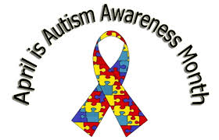
The Autism Society of America launched a nationwide effort to promote awareness about Autism and advocate for people with autism to achieve the highest quality of life possible in 1970. Since then, they have continued efforts to spread awareness, promote acceptance, and ignite change.
On March 4, 2021, the Autism Society announced a formal shifting from “Autism Awareness Month” to “Autism Acceptance Month.” According to the Autism Society, the “shift in the use of terminology aims to foster acceptance to ignite change through improved support and opportunities in education, employment, accessible housing, affordable health care and comprehensive long-term services.”
The April 2021 theme for Autism Acceptance Month is “Celebrate Differences.”
According to the Autism Society, the prevalence of Autism has risen from 1 in 125 children in 2010 to 1 in 59 in 2020 in the United States. About 1 percent of the world population has autism spectrum disorder.
The Light It Up Blue initiative was created by Autism Speaks in 2010 and has encouraged hundreds of thousands of landmarks, buildings, homes and communities around the world to shine a blue light on World Autism Awareness Day.
Consider observing Autism Acceptance Month in one or more of the following ways:
- Wear blue or shine a blue light on Friday, April 2
- Learn more about Dr. Temple Grandin who is known for her trailblazing work as a spokesperson for people with autism and her work with animal behavior. She has been dedicated to understanding her autistic mind and sharing that knowledge with the world. Dr. Grandin is one of the most respected experts in both autism and animal behavior in the world. She has written many books, given TED Talks and other interviews, many of which can be found on YouTube, including one titled Temple Grandin On Her Search Engine a short, 6 minute video. Temple co-wrote a book about her life with Margaret M. Scariano, titled “Emergence: Labeled Autistic” which was made into a movie titled “Temple Grandin” and stars Claire Danes
- The Netflix show “Love on the Spectrum” follows several young adults as they navigate dating and relationships

