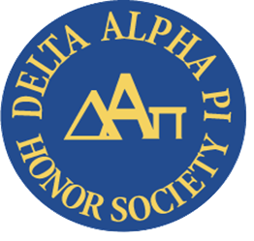
Richland’s Delta Alpha Pi Club works to raise awareness about disability and disability-related issues. The Delta Alpha Pi Disability Advocacy and Awareness Club is open to all students. Meetings are on the third Wednesday of the month at 3pm via Zoom. If you would like to join or learn more about Delta Alpha Pi, please email tmata@richland.edu.

December 3rd is International Day of Persons with Disabilities. The annual observance was proclaimed in 1992 by the United Nations General Assembly. The goal, per the United Nations, is “to promote an understanding of disability issues and mobilize support for the dignity, rights and well-being of persons with disabilities.”

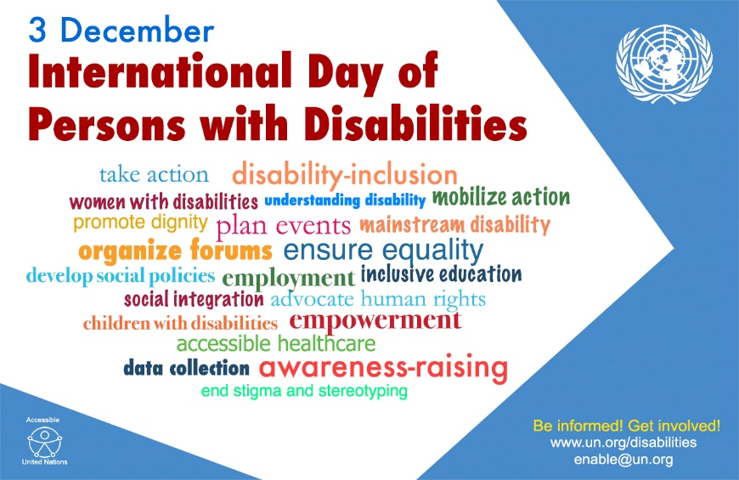

More than one billion people, or roughly 15-20%, of the world’s population experiences some form of disability. In the United States, according to the CDC, 61 million adults or 26% (1 in 4) have been diagnosed with a disability. Nineteen percent of college students reported having a disability.

Consider taking a moment today to learn more about disability issues. You can watch this short video, Be Cool, We are 2019, made for Indiana Disability Awareness Month which features people with disabilities addressing the issue of how to act around them. Or check out this comedy routine by Josh Blue, winner of the 4th season of Last Comic Standing, When You Feel Obligated To Be Disabled.

Netflix also has a great documentary about disability issues: Crip Camp: A Disability Revolution (Rated R), highlights a summer camp for teens with disabilities, Camp Jened, in 1971 and follows some of the campers who became activists for the disability rights movement and their fight for disability and accessibility legislation.

