Richland’s Delta Alpha Pi Club works to raise awareness about disability and disability-related issues. March is the awareness month for both Brain Injury and Cerebral Palsy. Delta Alpha Pi is proud to highlight Brain Injury and Cerebral Palsy Awareness. If you would like to join or learn more about Delta Alpha Pi, please email tmata@richland.edu.

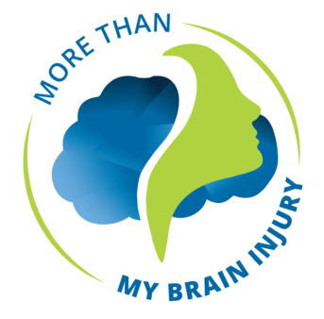
Facts about Brain Injury from the Brain Injury Association of America:
- There are more than 5.3 million children and adults in the United States who are living with a permanent brain injury-related disability. Every 9 seconds, someone in the United States sustains a brain injury
- The theme for the 2021-2023 Awareness Campaign is More Than My Brain Injury.
- An acquired brain injury (ABI) is an injury to the brain that is not hereditary, congenital, degenerative, or induced by birth trauma. Essentially, this type of brain injury is one that has occurred after birth. There are two types of acquired brain injury: traumatic and non-traumatic. More than 3.6 Million people sustain an ABI each year
  - A traumatic brain injury (TBI) is defined as an alteration in brain function, or other evidence of brain pathology, caused by an external force or trauma. Traumatic impact injuries can be defined as closed (or non-penetrating) or open (penetrating). At least 2.8 Million people sustain a TBI each year
    - Leading causes of TBI include Falls 47.9%, Struck By or Against 17.10%, Unknown or Other 13.2%, Motor Vehicle 13.2%, and Assaults 8.3%
  - Often – and somewhat confusingly – referred to as an acquired brain injury, a non-traumatic brain injury causes damage to the brain by internal factors, such as a lack of oxygen, exposure to toxins, pressure from a tumor, etc. More than 3.6 Million people sustain an ABI each year
- Typical causes of Acquired Brain Injury include: Electric Shock, Infectious Disease, Lightning Strike, Oxygen Deprivation, Toxic Exposure, Vehicle Accidents, Seizure Disorder, Trauma, Substance Abuse or Overdose, or Stroke
Dozens of stories from people or family members of people who have sustained a brain injury have been collected on the Personal Stories page on the Brain Injury Associates of America website. Please consider taking a moment to read about their journeys.
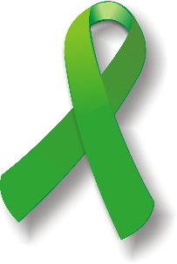
Cerebral Palsy
Facts about Cerebral Palsy according to Cerebral Palsy Guide and the CDC’s page about Cerebral Palsy:
- Cerebral palsy (CP) is the most common motor disability in childhood and is a group of disorders that affect a person’s ability to move and maintain balance and posture
- Over 1 million people in the United States are living with Cerebral palsy; about 1 in 323 children has been identified with CP
- The symptoms of CP vary from person to person and may change over a person’s lifetime
- There are 3 types of cerebral palsy
  - Spastic CP is characterized by still muscles and affects about 80% of people with CP
  - Dyskinetic CP is characterized by difficulty controlling movements
  - Ataxic CP is characterized by difficulty with balance and coordination
  - It is also possible to have symptoms of more than one type of CP. The most common type of mixed CP is spastic-dyskinetic CP
- March 25 has been established as National Cerebral Palsy Awareness Day and people are encouraged to wear the color Green to show their support
Check out this video from Zach Anner, “Top 10 Things I Wish People Knew About Cerebral Palsy”

