Steps to Access NetTutor
- Log into Canvas and click on dashboard on the left hand side.
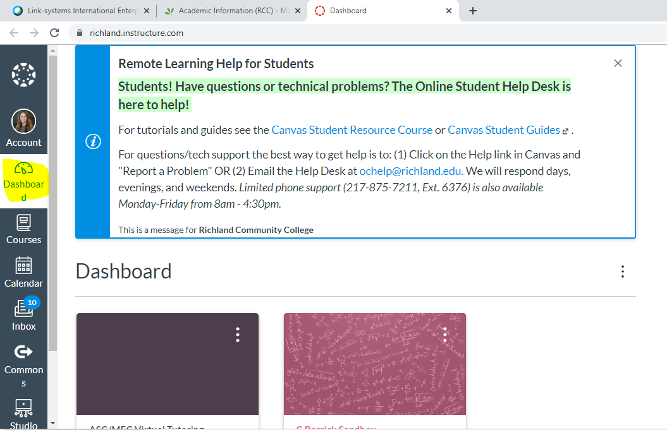
- Scroll down and click on Canvas Student Resources.
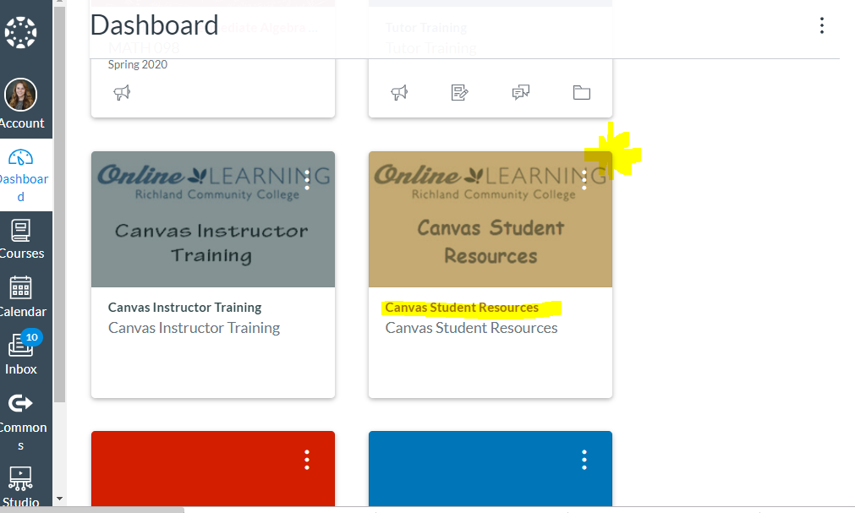
- Click on NetTutor.
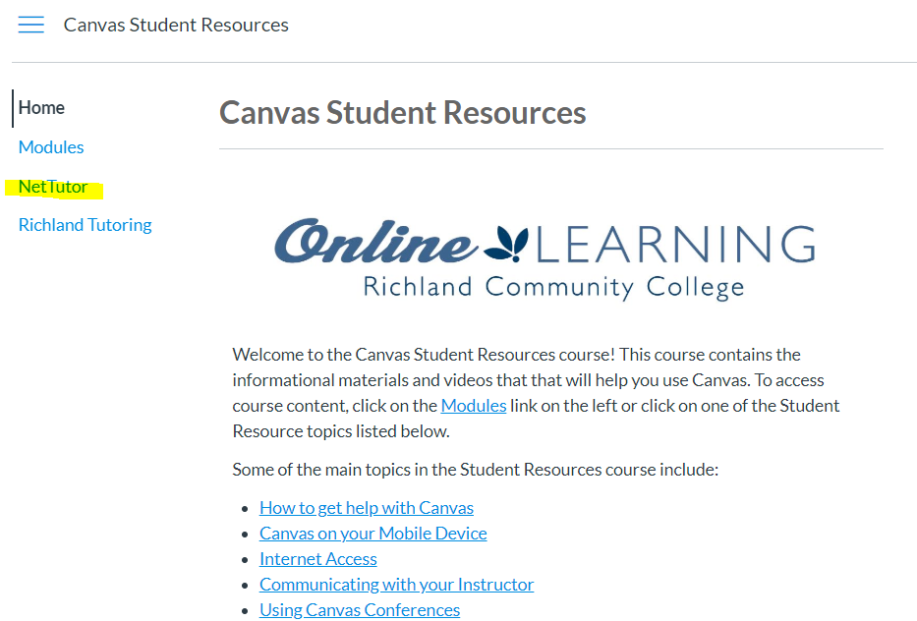
- Follow on-screen prompts.

